California Geological Survey
Earthquake Quick Report: M5.9 Minden CA, “SSW of Smith Valley, NV”

7/8/21
Contributors: Cynthia Pridmore (CGS), Jason Patton (CGS)
Time report sent:5:17

General Description
Magnitude M5.9
2021-07-08 at 15:49:48 (UTC- 7:00)
Depth: 9.8 km
Location: ~2km WNW of Minden CA
Sense of motion: extensional normal fault motion
Ground acceleration nearest epicenter: 0.042 g from nearest strong motion station 37.8km (Bridgeport -Main & School Street, 65654)
Nearest major fault: epicenter likely within Holocene Antelope Valley Fault Zone, part of the eastern Sierra frontal fault zone

Aftershocks (time sensitive, more may occur at or shortly after this report is sent out):
Largest aftershock: M4.6
Number of aftershocks at time of report: 34 (range of magnitudes M1.6-M4.6)

USGS Felt Reponses 15164 (at 5:03pm)
This event was widely felt, lightly from Eureka to Southern California, and from San Francisco to Central Nevada. Strongest reported felt shaking near epicentral area: MMI Intensity VI “felt as strong shaking”

Links:
CESMD event page: https://www.strongmotioncenter.org/cgi-bin/CESMD/iqr_dist_DM2.pl?ID=nc73584926
USGS event page: https://earthquake.usgs.gov/earthquakes/eventpage/nc73584926/executive
Summary report poster (attached)
CESMD Shake Map:
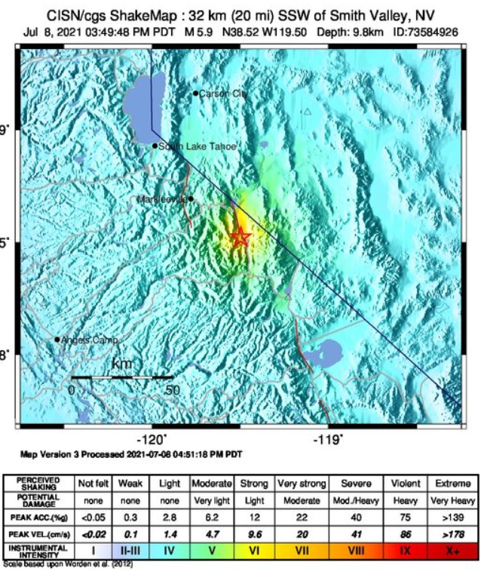

USGS Felt Map:
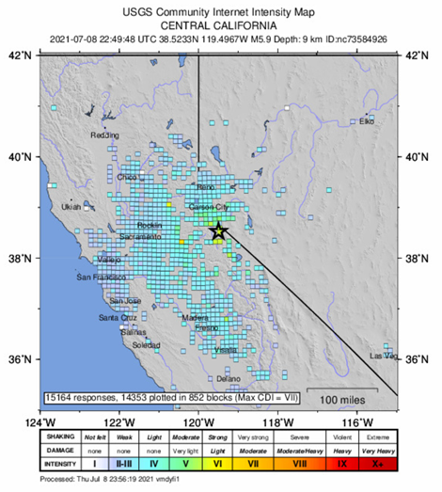

Summary Event Poster (Jason Patton, CGS)
