Supplement Figures
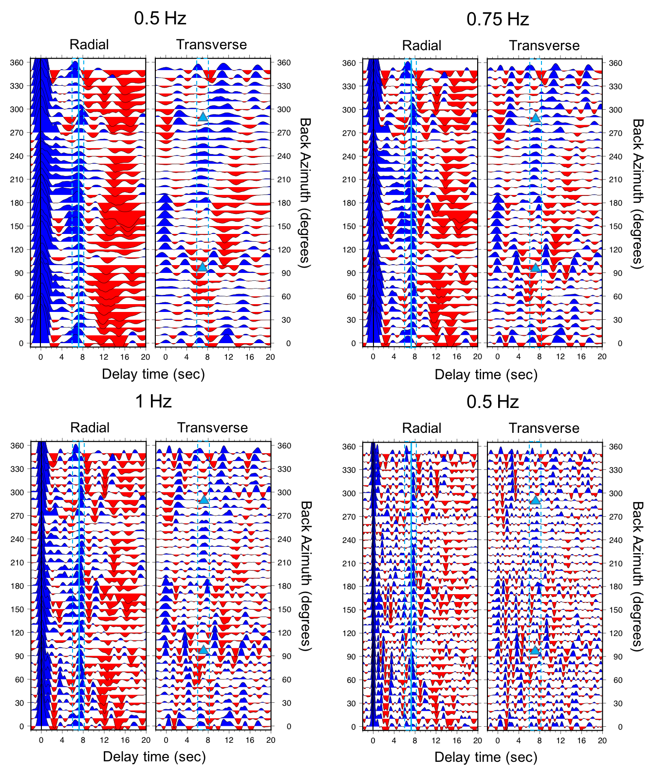
Figure S1: Quasi radial (left panels) and transverse (right panels) component RF gathers for station LPAZ, binned by backazimuth, for a series of different cutoff frequencies (0.5, 0.75, 1 and 2 Hz, see labels). Plotting conventions are as in Figure 3a of the main text.
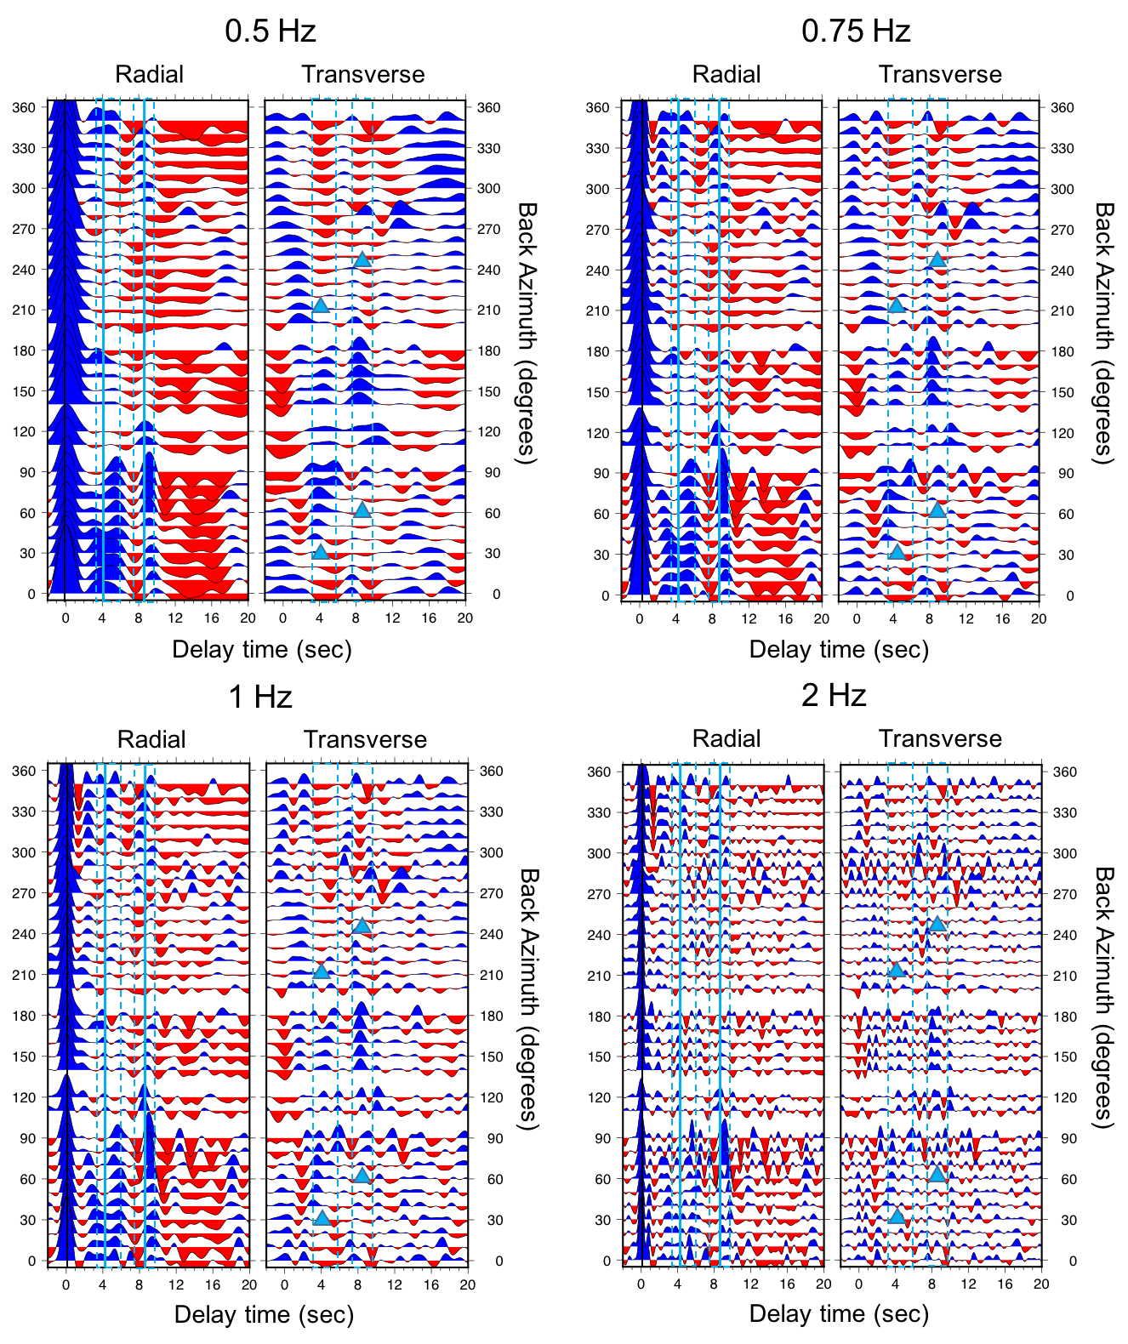
Figure S2: Quasi radial (left panels) and transverse (right panels) component RF gathers for station NNA, binned by backazimuth, for a series of different cutoff frequencies (0.5, 0.75, 1 and 2 Hz, see labels). Plotting conventions are as in Figure 7a of the main text.

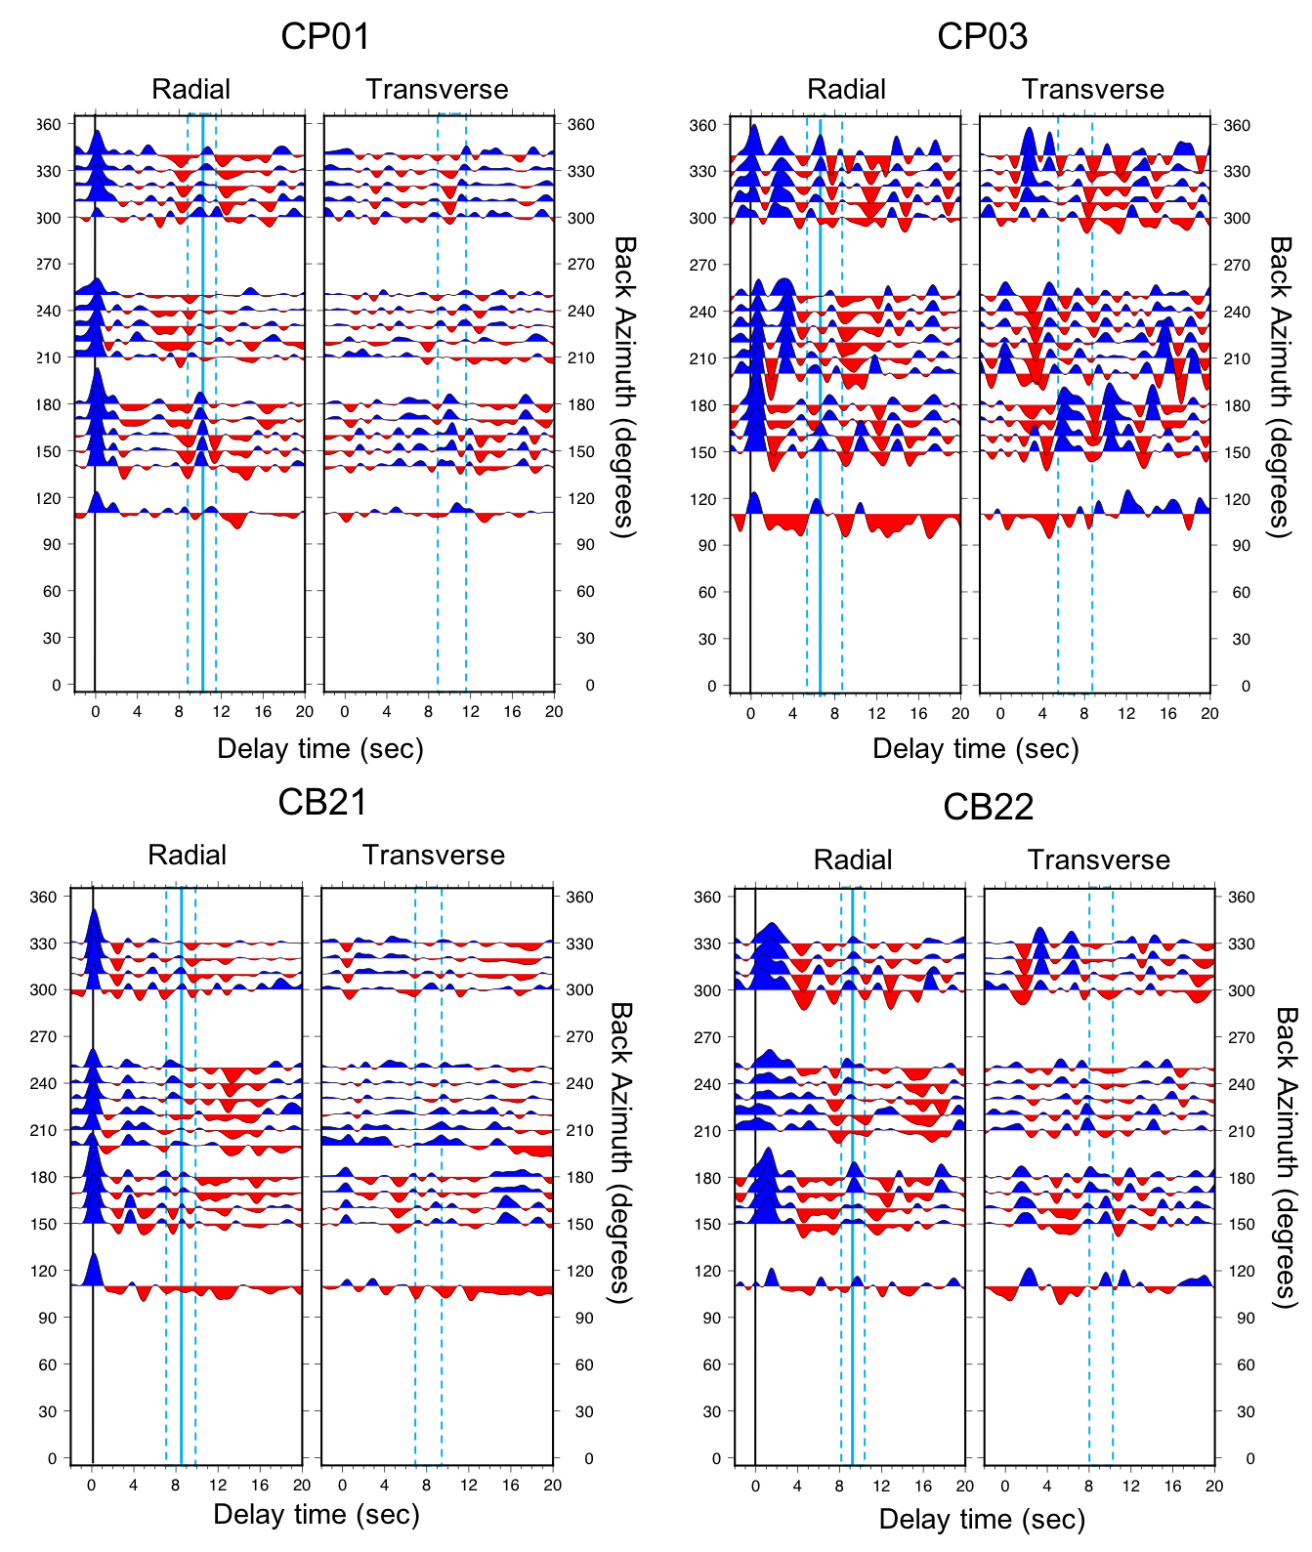
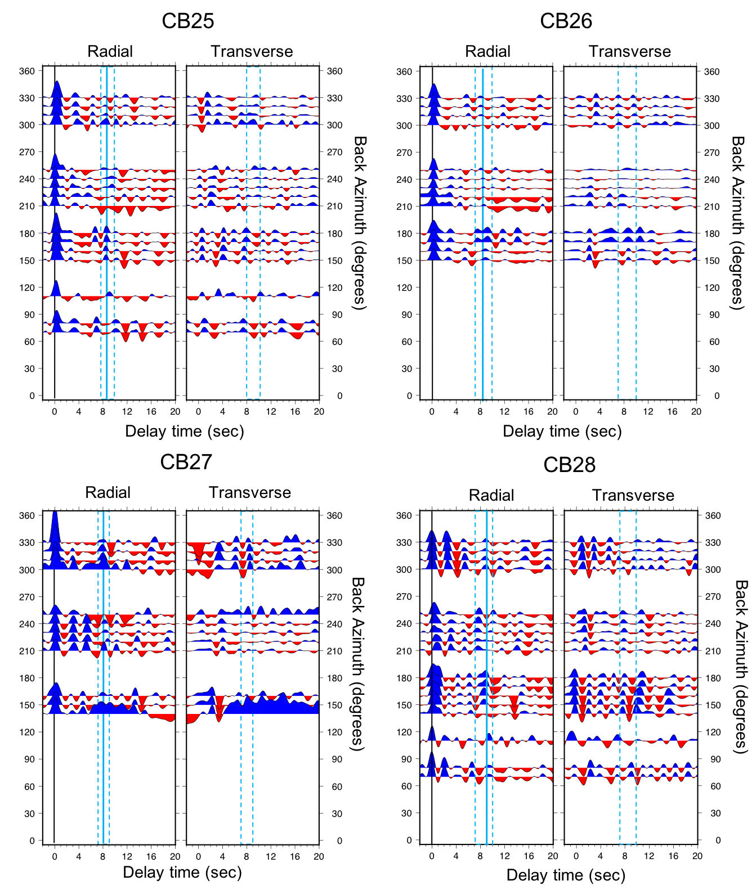
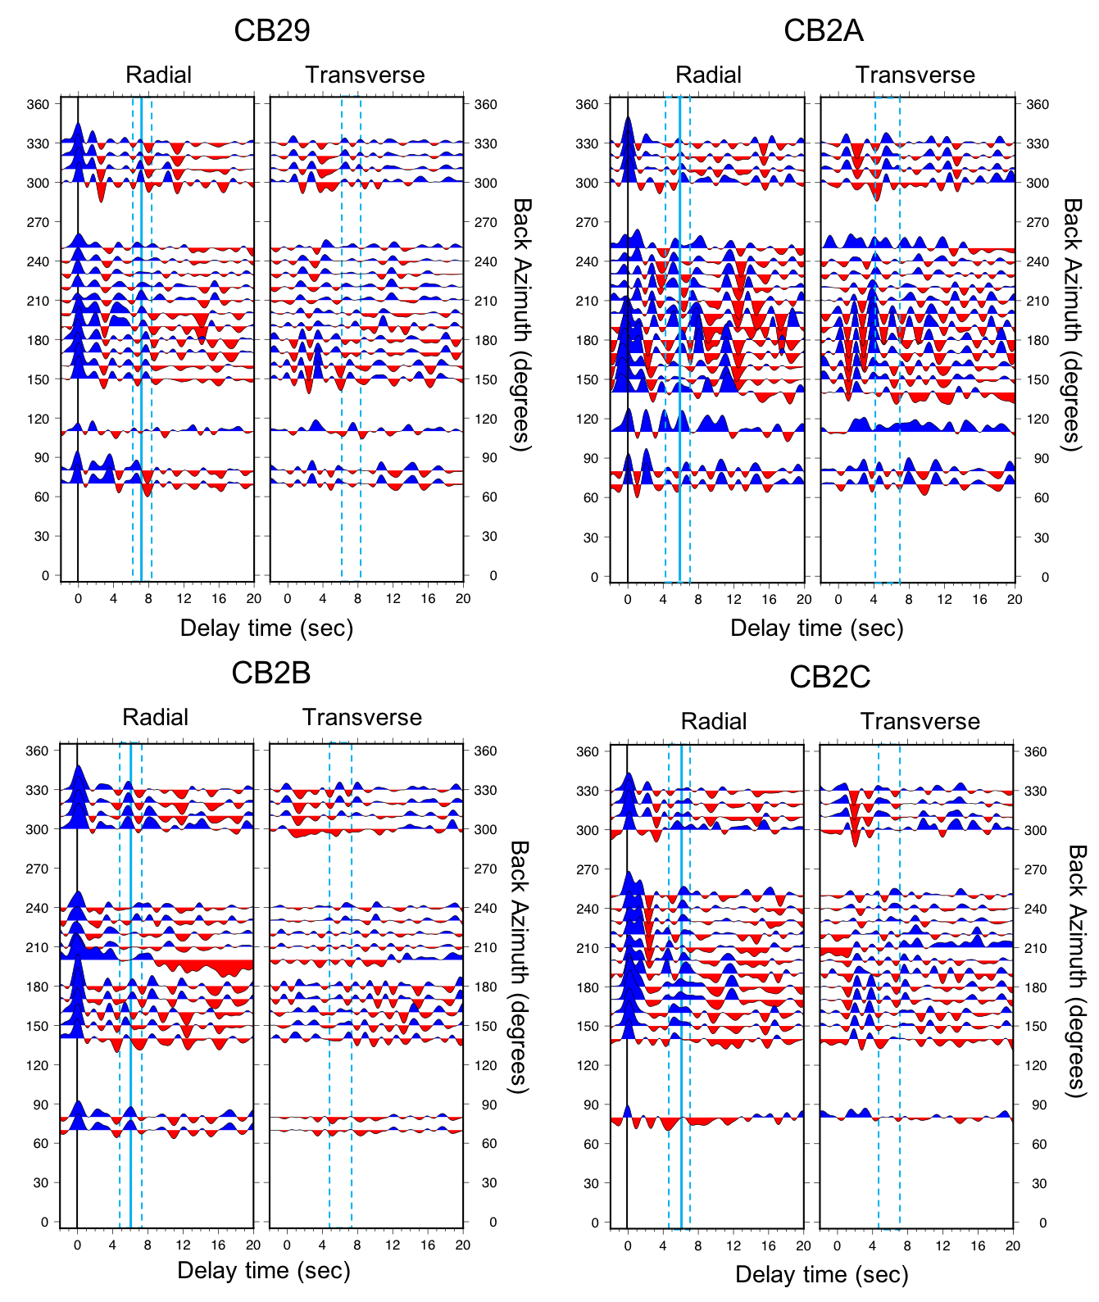
Figure S3: Results of our RF analysis for CAUGHT temporary stations, with an emphasis on characterizing the Moho arrival. Quasi-radial (left) and transverse (right) component RFs, that have been migrated, gathered in backazimuthal bins (as indicated on y axis), and stacked. Plotting conventions are as in Figure 3.
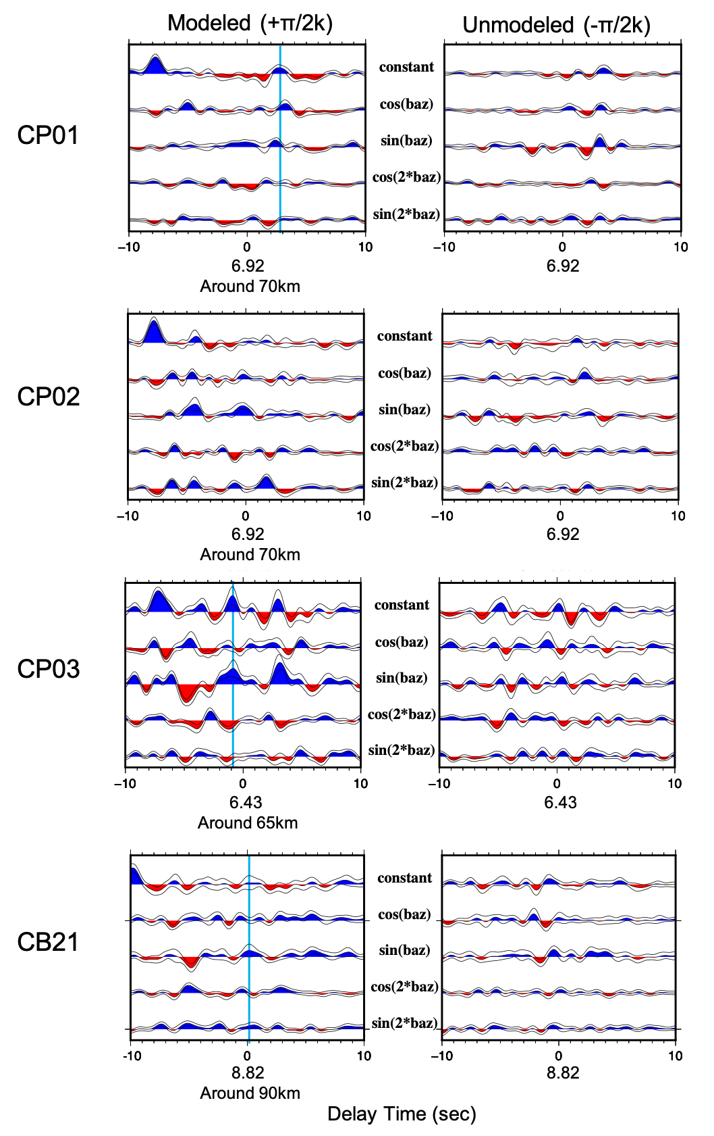
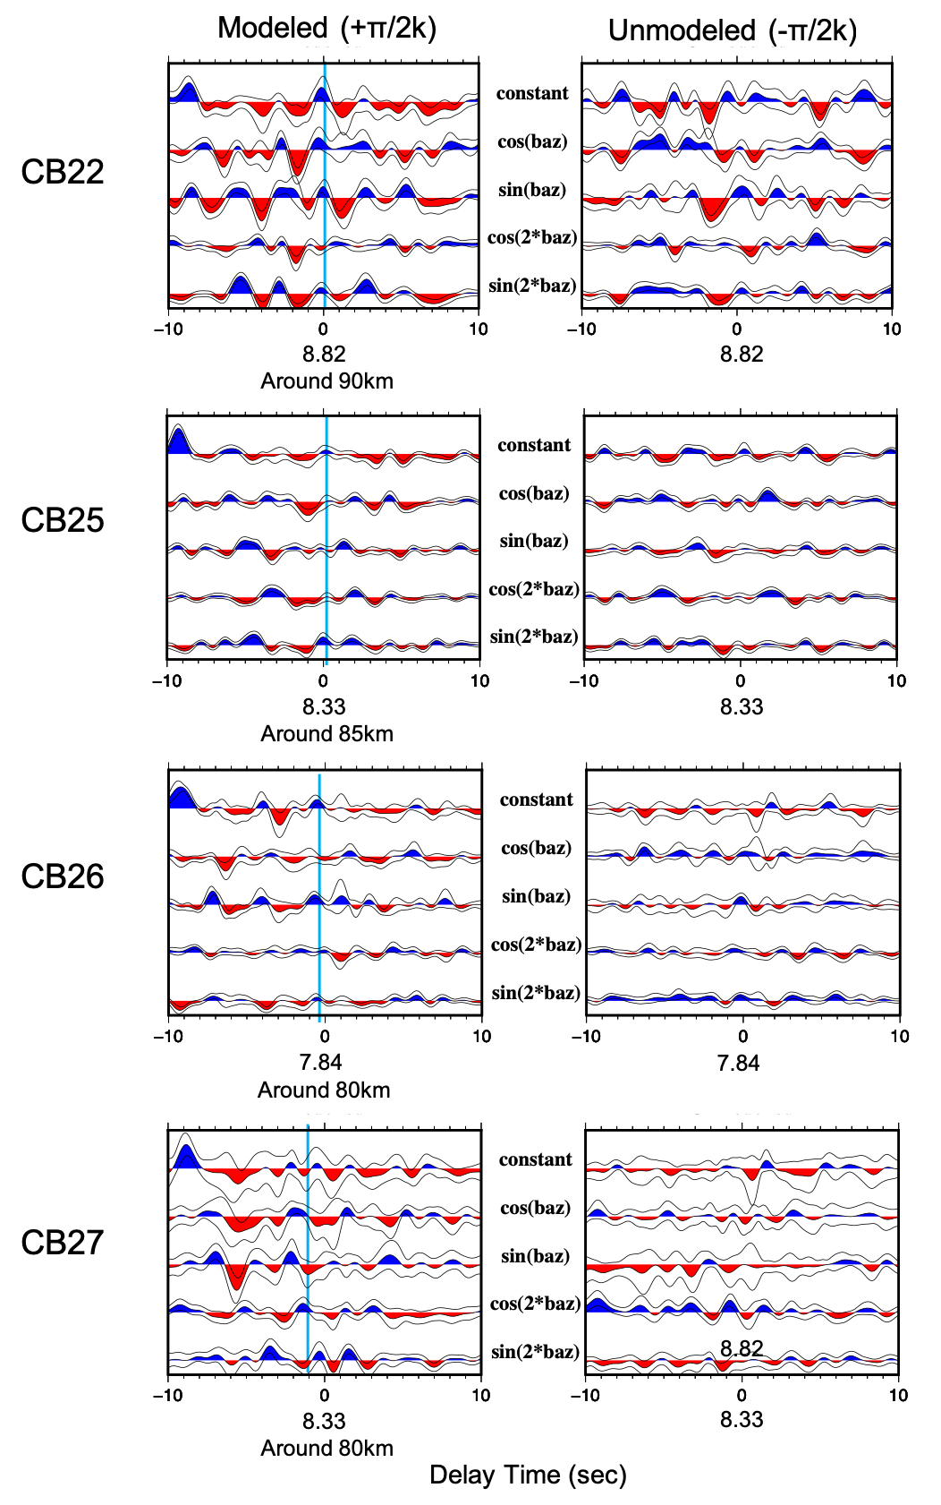
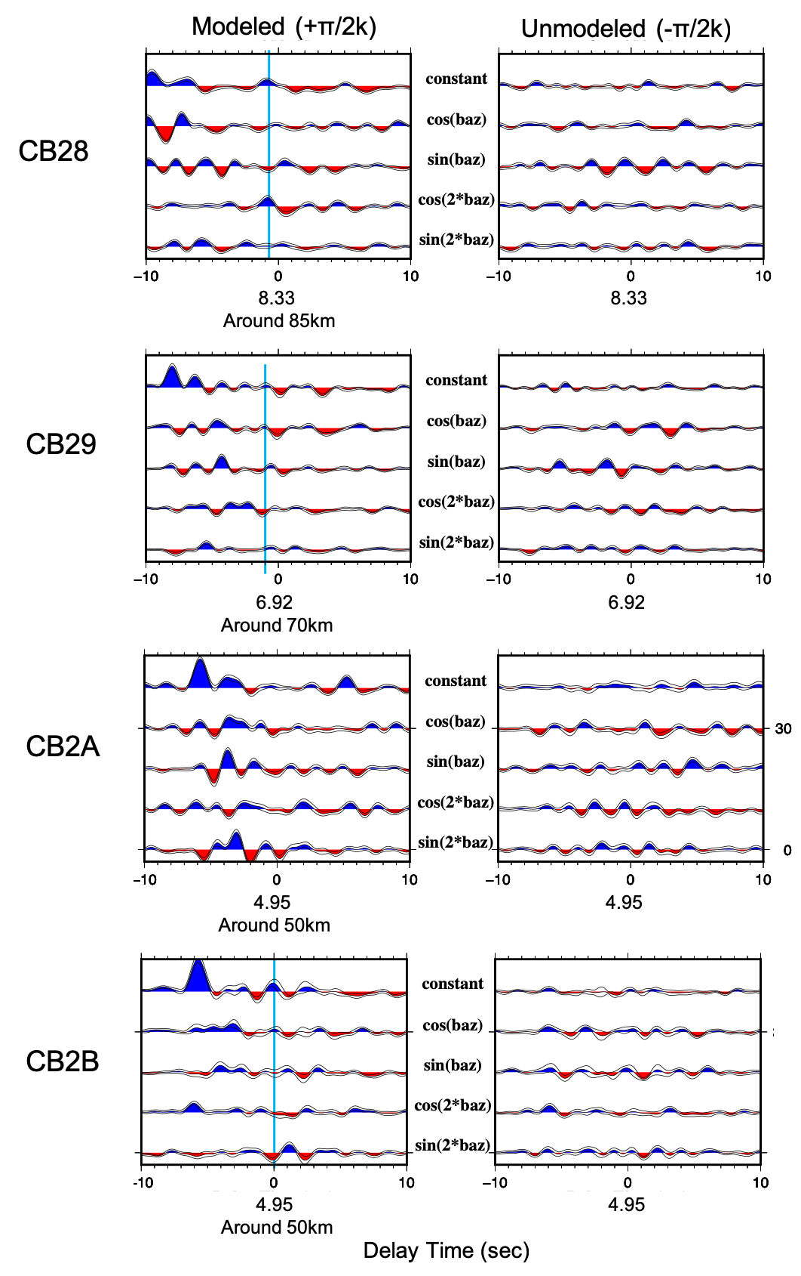

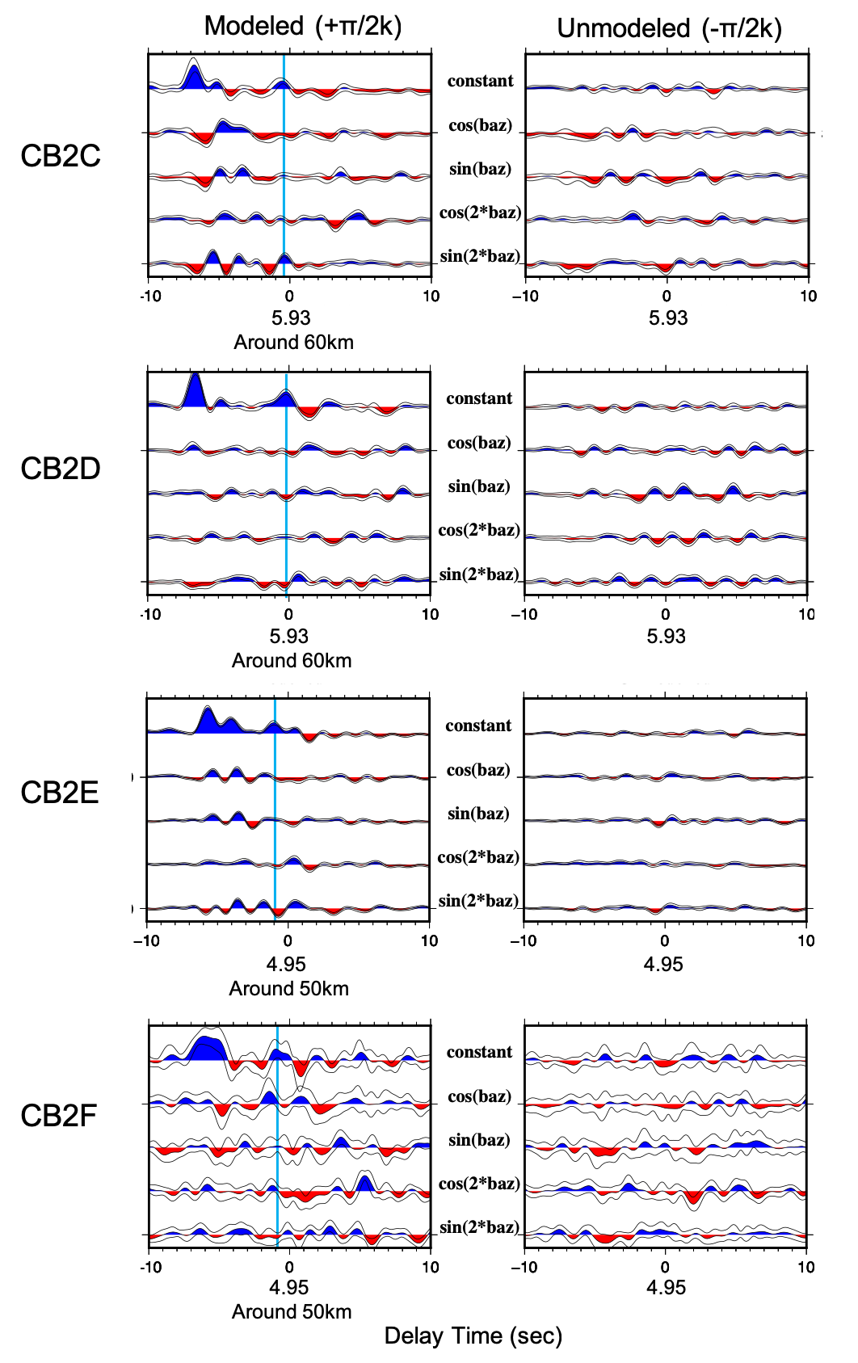
Figure S4: Harmonic decomposition results beneath CAUGHT temp stations, computed around target depths corresponding to the Moho (see labels) based on the RFs (see supplement fig. S3). Left panels show the modeled (+π/2k) portion of the HD on the left, with the top trace corresponding to the k = 0 (constant) term, the next two traces corresponding to the k = 1 terms, and the final two traces corresponding to the k = 2 terms. The right panels show the unmodeled or suppressed (-π/2k) portion of the HD. Beneath each time axis, we show the center time associated with the target depth (in sec) beneath the t = 0 reference time. The cyan line marks the Moho (near a delay time of zero sec on the x axis; here a zero sec delay time corresponds to the expected arrival time for a conversion at the target depth).

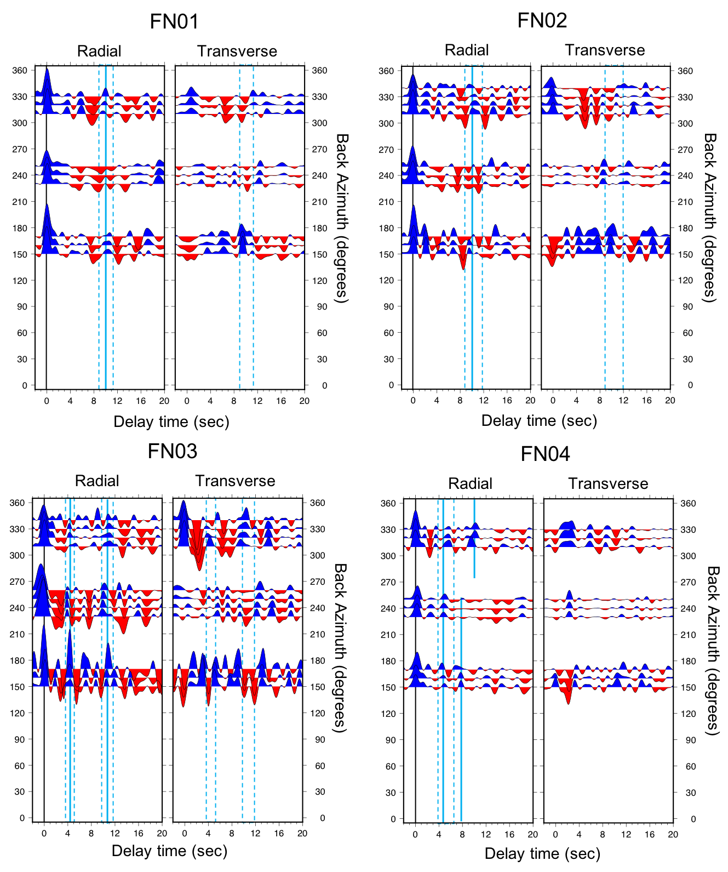
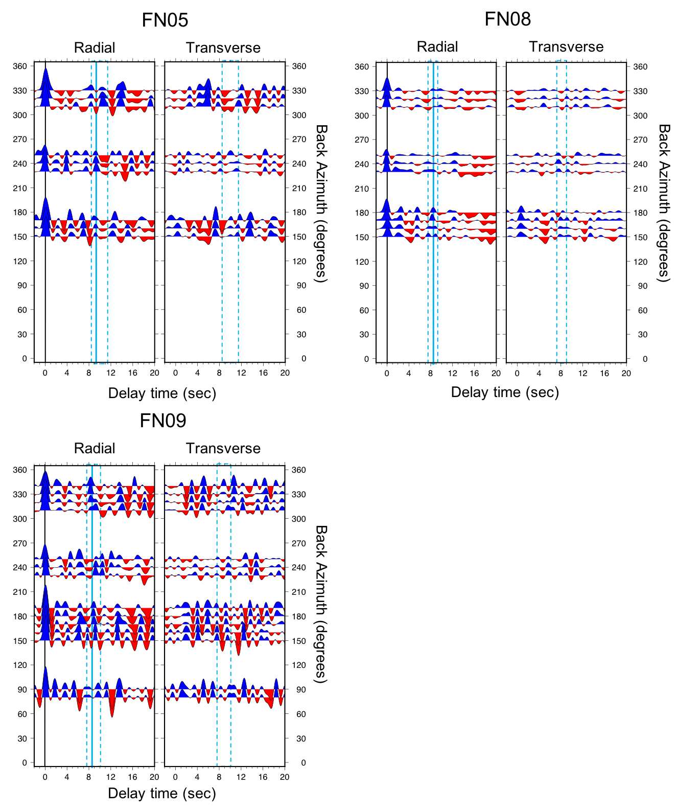
Figure S5: Results of our RF analysis for PULSE temporary stations, with an emphasis on characterizing the subducting slab Moho arrival. Quasi-radial (left) and transverse (right) component RFs, that have been migrated, gathered in backazimuthal bins (as indicated on y axis), and stacked. Plotting conventions are as in Figure 3.
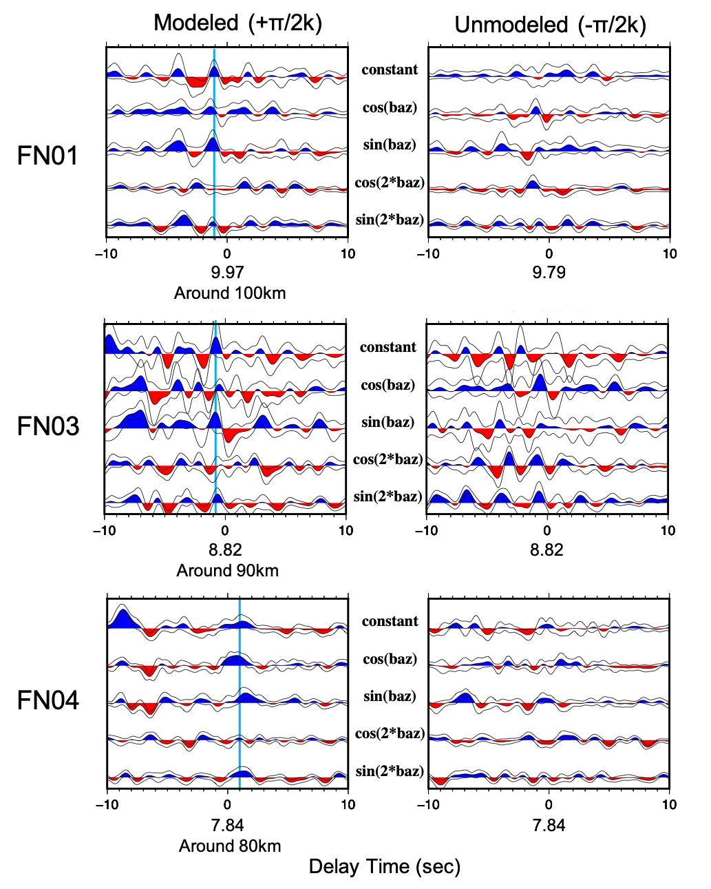
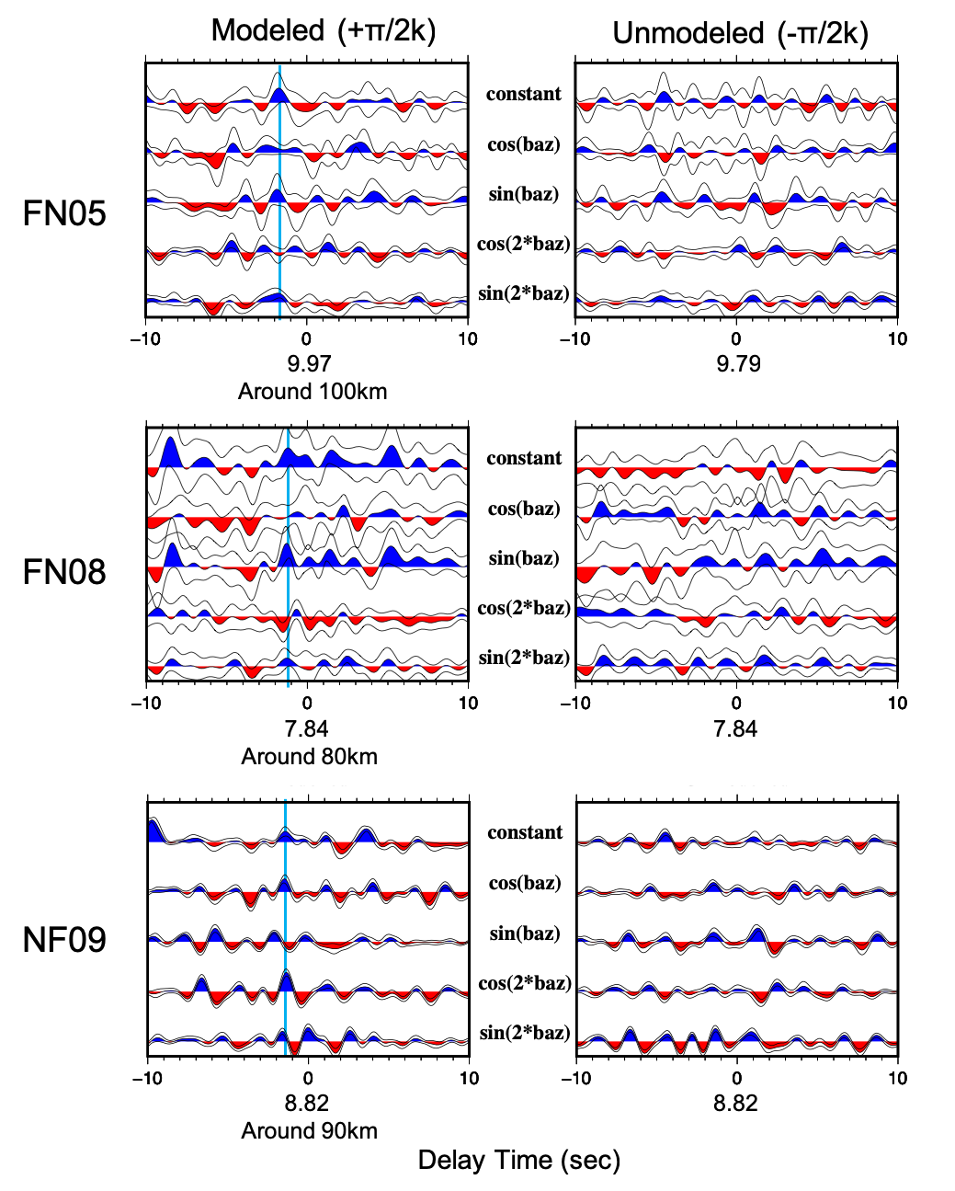
Figure S6: Harmonic decomposition results beneath PULSE temp stations, computed around target depths corresponding to the subducting slab Moho (see labels) based on the RFs (see supplement fig. S5). Left panels show the modeled (+π/2k) portion of the HD on the left, with the top trace corresponding to the k = 0 (constant) term, the next two traces corresponding to the k = 1 terms, and the final two traces corresponding to the k = 2 terms. Plotting conventions are as in Figure S3.

